The 8th China International Exhibition on Nuclear Power Industry 2009

第 八 届 中 国 国 际 核 电 工 业 展 览 会
<NUCLEAR 2009>

April 19-22, 2009 China International Exhibition Center, Beijing, P.R. China

Exhibitor’s Registration / Badge Collection 参展商登记 / 领取展商证

- Please go to the ticket counter at the Jingan West Street entrance of China International Exhibition Center (CIEC) to redeem an electronic ticket.
(Always keep the electronic ticket for the next entry)
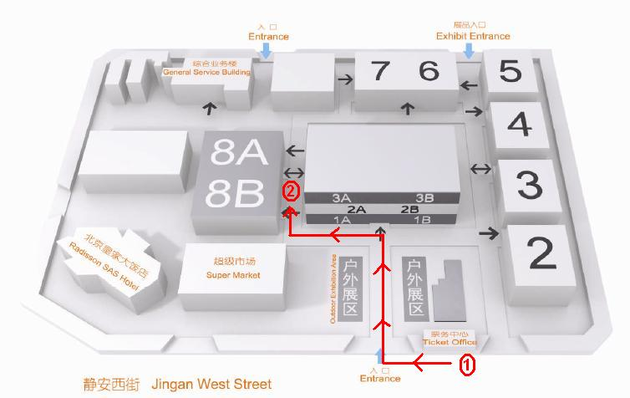
- Proceed to the registration counter at the main entrance of Hall 8 and collect your badge(s) there.
- 请先到中国国际展览中心售票窗口（静安西街入口）免费换取电子门票；
（每次入闸均需利用电子门票，请好好保管！）
- 再到8号馆登记以领取参展商证入场。

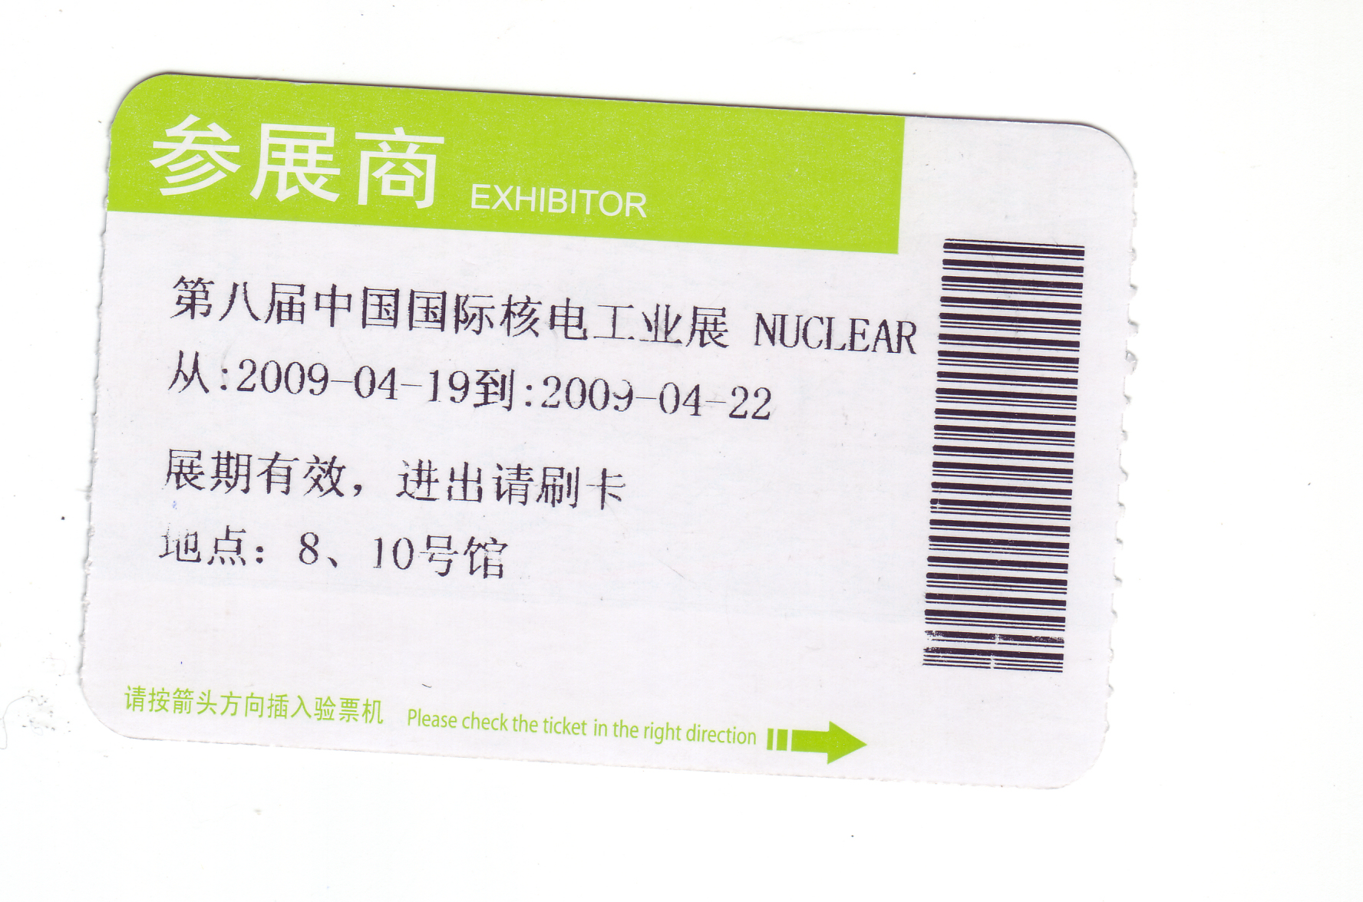
# For non-Mandarin speakers, please present the following at the ticket counter to redeem an electronic ticket:

你好！我是“核电展”参展商，请给我电子门票。 谢谢！

Opening Ceremony 开幕典礼

The Opening Ceremony is scheduled being held at 03:00p.m. on April 19, 2009 at Foyer of Hall 8 of China International Exhibition Center (CIEC). All Exhibitors are invited to attend the ceremony. 开幕典礼将于2009年4月19日下午三时整在8号馆前举行，欢迎所有展商出席。

Exhibition Opening Hours (for visitors) 展览会参观时间
2009.04.19 (Sunday 星期日) 15:30-17:00 (VIP)
2009.04.20 (Monday 星期一) 09:00-16:30 *
2009.04.21 (Tuesday星期二) 09:00-16:30 *
2009.04.22 (Wednesday星期三) 09:00-15:00 *
(* Exhibitors can enter the exhibition hall at 08:45 a.m. 参展商可于上午八时四十五分进场)

Decoration of Booth 展台布置
Constructed booths would be ready for decoration on 标准摊位参展商可于以下时间内进入展览场地布置:

2009.04.18 08:30-21:00

2009.04.19 08:30-12:00

Raw space exhibitors require early move-in; please contact the Official Stand Contractor for arrangements. Regarding additional orders for furniture, please contact the official Stand Contractor
净地参展商要求提早布展、展商租用家具供电等事项，请联络大会指定展览工程公司以作安排:

- PICO IES Group (China) Co., Ltd. Beijing Branch 笔克主建（上海）展览服务有限公司北京分公司
Contact联络人:
Ms. Mr. Frank Zhang 张韬先生 Tel 电话: (86)(10) 8484 7975 (ext 1007) / 86-13146129625
Fax 传真: (86)(10) 84847957 E-mail 电邮: frank.zhang@cn.pico.com
Ms. Emme Liu 刘慧小姐 Tel 电话: (86)(10) 8484 7975 (ext 1005) / 86-15010462146
Fax 传真: (86)(10) 84847957 E-mail 电邮: emme.liu@cn.pico.com
or the on-site office或或其它在场职员

Exhibits Move in & Move out Schedule 布展及撤馆安排

Shell Scheme Move-in Dates 标准摊位参展商布展: 2009.04.18 08:30-21:00

2009.04.19 08:30-12:00

Raw Space Move-in Dates 净地参展商布展: 2009.04.17 14:00-17:30

2009.04.18 08:30-21:00

2009.04.19 08:30-12:00

Move-out Date 撤馆: 2009.04.22 15:00-21:00

For all freight forwarding arrangements, please contact the official Freight Forwarder
所有展品运输安排，请联络大会指定运输公司:

Rogers Worldwide (Hong Kong) Ltd. 罗杰斯环球(香港)有限公司
Contact联络人:
Ms. Karen Zhang 张小梅小姐 Tel 电话: 86-1358 156 3894 E-mail 电邮: karen@rogersbjg.com
Mr. Johnny Lam 林海亮先生 Tel 电话: 86-1360 115 6807 E-mail 电邮: johnny@rogersbjg.com
or the on-site office或或其它在场职员

Hotel Accommodation Arrangement 酒店住宿安排

贵国酒店
Tel 电话: (86)(10) 84512866转张京昊

Radisson SAS Hotel Beijing 北京皇家大饭店
Tel 电话: (86)(10) 5922 3388 Fax 传真: (86)(10) 8460 2346
E-mail 电邮: reservations.beijing@radissonsas.com

承办单位
For any information and assistance during the exhibition, please contact 展览期间如有其它查询和协助，请联络:
国家国家原子能机构新闻中心
Tel电话: (010)88581492 13426492630 Fax传真: (010) 88582388

